**CENWP-OD-B 12 September 2024**

**MEMORANDUM FOR THE RECORD**

**SUBJECT: 24BON051 MFR AFF Valve 15 Chinook Salmon Mortality**

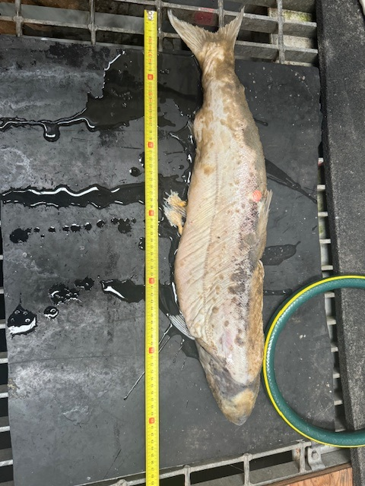On the morning of 12 September 2024, CRITFC Biologists notified Project Biologists of one adult Chinook salmon mortality discovered on the Adult Fish Facility’s valve 15 trash rack. The fish was measured, scanned for PIT tags, inspected, and returned to the river.

1. Species – Chinook Salmon (*Oncorhynchus tshawytscha*)
2. Origin – Unknown
3. Length – approximately 63 cm total length
4. Marks and tags – Clipped adipose fin, no tag detection
5. Marks and Injuries found on carcass – N/A
6. Cause and Time of Death – Unknown
7. Future and Preventative Measures – N/A

Sincerely,

Bonneville Project Fisheries